**Ahsanullah University of Science & Technology Department of Computer Science & Engineering Semester Spring 2021**



# CSE 3216

**Microcontroller Based System Design Lab**

**Project Proposal**

**Project Name: Smart Blind Stick**

**Submitted To**

**Ashna Nawar Ahmed**  **Farzad Ahmed**

Lecturer Lecturer CSE, AUST CSE, AUST

**Submitted By**

|  |  |
| --- | --- |
| **Md. Mominul Islam Shizan** | **18.02.04.117** |
| **Afridi Rahman Bondhon** | **18.02.04.128** |
| **Nurul Amin** | **18.02.04.130** |
| **Mosiur Rahman** | **16.01.04.122** |

# Objective

In the current scenario, there is need of a personal guide for blind people. This project presents smart electronic aid for blind people. Smart Blind Stick for people who are blind is an innovation which helps the blind people to navigate with speed and confidence by detecting the nearby obstacles using the help of ultrasonic waves and notify them with buzzer sound or vibration and GPS helps them if they are lost. They only need to keep this stick in their hand.

# Social Values

According to WHO 39 million peoples are estimated as blind worldwide. They are suffering a lot of hardship in their daily life.

The affected ones have been using the traditional white cane for many years which although being effective, still has a lot of disadvantages. Another way is, having a pet animal such as a dog, but it is really expensive. So the aim of the project is to develop a cheap and more efficient way to help visually impaired to navigate with greater comfort, speed and confidence.

# Required Components

These following parts and tools are required for building this project

* Arduino UNO
* Ultrasonic Sensor
* Water Level sensor
* PVC Pipe
* Jumper wire
* 9 Volt Battery (2 piece)
* Switch
* Mini Servo SG90
* Hand Gloves
* Scotch Tape

##### Working Procedure

##### Our system will perform following action

* **Ultrasonic Sensor :** An Ultrasonic sensor is a device that can measure the distance to an object by using sound waves. It measures distance by sending out a sound wave at a specific frequency and listening for that sound wave to bounce back. By recording the elapsed time between the sound wave being generated and the sound wave bouncing back, it is possible to calculate the distance between the sonar sensor and the object.
* **Buzzer:** Buzzer will alarm ring when any obstacle detect in front of sensor.
* **Mini Servo SG90:** It will move his hand towards left or right. A person will feel in which direction to go.
* **Water Sensor:** It will detect if there is any water in his way
* **GSM & GPS:** It Will Send location to his saved number.

# Diagram

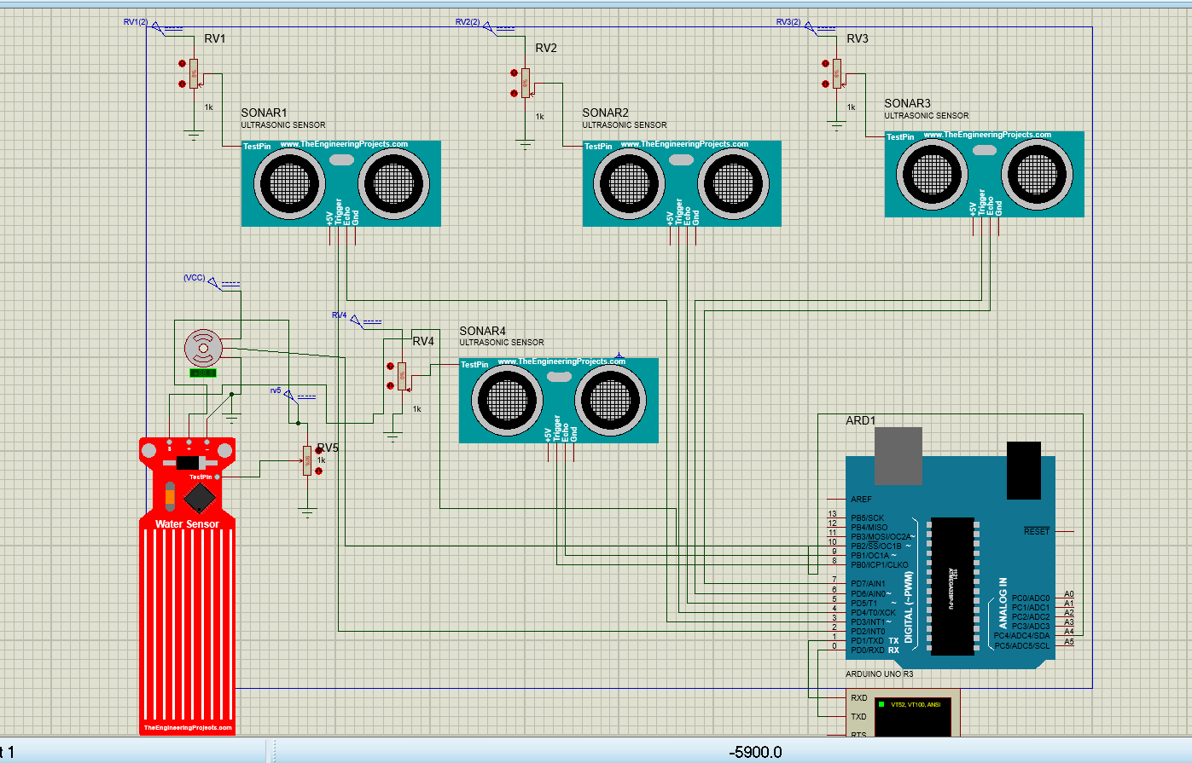

# Estimated budget

|  |  |  |  |  |  |
| --- | --- | --- | --- | --- | --- |
| **Initial Equipment** | **Initial Quantity** | **Initial Budget (Tk)** | **Final Equipment** | **Final Quantity** | **Final Expenditure (Tk)** |
| Arduino UNO | 1 | 670 | Arduino UNO | 1 | 800 |
| PVC Pipe | 1 | 100 | PVC Pipe | 1 | 90 |
| Ultrasonic Sensor | 7 | 700 | Ultrasonic Sensor | 4 | 300 |
| GPS & GSM | 1 | 1930 | x | x | x |
| Jumper wire | As required | 100 | Jumper wire | As required | 90 |
| 9 Volt Battery | 1 | 40 | 9 Volt Battery | 2 | 140 |
| Switch | 1 | 5 | Switch | 1 | 10 |
| Mini Servo SG90 | 1 | 195 | Mini Servo SG90 | 1 | 120 |
| Water level sensor | 1 | 250 | Water level sensor | 1 | 100 |
| Active Buzzer | 1 | 15 | x | x | x |
| Resistor | As required | 20 | x | x | x |
|  |  |  | Scotch Tape | 2 | 40 |
|  |  |  | Hand Gloves | 1 | 40 |
| **Total** |  | **4025** |  |  | **1730** |

# Contribution

**MD. Mominul Islam Shizan - 18.02.04.117 25%**

**Afridi Rahman Bondhon - 18.02.04.128 25%**

**Nurul Amin - 18.02.04.130 25%**

**Mosiur Rahman - 16.01.04.122 25%**

# Challenges

* Unfortunately, due to a loose connection, the sensor did not operate when everything was adjusted together.
* Because of the low power supply, the servo motor did not operate.
* When there is no water, the water sensor detects water automatically.

**Conclusion**

This Arduino Based Smart Blind Stick project proposed the design and architecture of a new concept of Smart Stick for blind people. The advantage of this project lies in the fact that it can prove to be a very low cost solution to millions of blind person worldwide. This system enables the blind people to move with same ease and confidence as sighted people.